

Dr. Xueliang CHENG

*as a trainee of the NEST/ARTERD training program on*

*"Robotics & Remote System: Research on Robot Navigation for Distributed Radiation Mapping".*

*Nov. 18, 2022*

SIGNATURE

SIGNATURE

Certificate of Completion

THIS CERTIFICATE IS PROUDLY PRESENTED TO

SIGNATURE

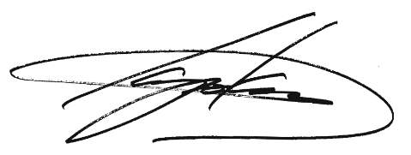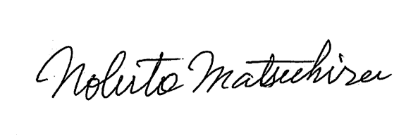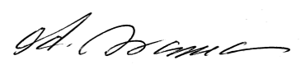

**Koji OKAMOTO**

Director General, CLADS, JAEA

**Hajime ASAMA**

Professor, The University of Tokyo

**Nobuto MATSUHIRA**

Project Researcher, The University of Tokyo